'Youth in Action' Programme  Action 1.1 | 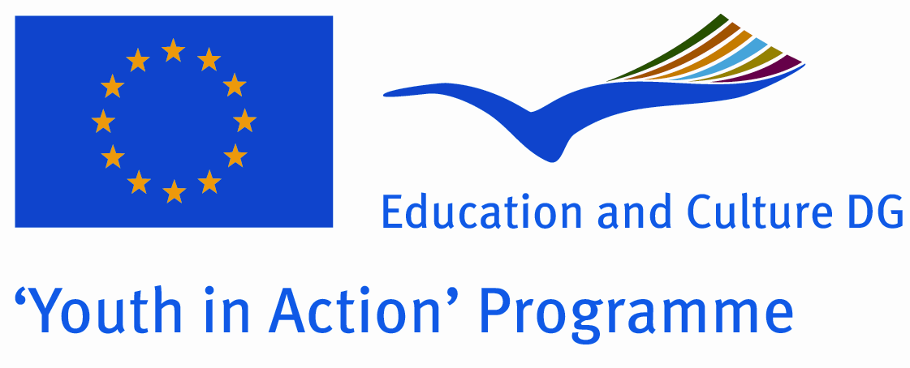

CALL FOR PARTNERS

Project name:
Youth Exchange
INTERCULTURAL DIALOGUE, INTER-RELIGIOUS CO-OPERATION
AND CULTURAL DIFFERENCES

July 2011, Bulgaria

MAIN ACTIVITIES:

Youth Exchange:
INTERCULTURAL DIALOGUE, INTER-RELIGIOUS CO-OPERATION
AND CULTURAL DIFFERENCES

Programme: Youth in Action 1.1
It is in this spirit that the aim of this exchange is to train and empower minority youth leaders to develop projects and associative strategies committed to the advancement of a civil society based on participation, intercultural education and Human Rights in a European perspective. The project and commitments resulting from this exchange will create synergies to help overcome situations of exclusion and discrimination caused by INTERCULTURAL DIALOGUE, INTER-RELIGIOUS CO-OPERATION AND CULTURAL DIFFERENCES.

The concrete objectives of the training course are:

- to support/promote minority youth participation, within the framework of consolidation of civil society;
- to discuss and enhance the representation of minority youth in European youth associations and structures;
- to reflect on issues such as identity, nationalism, Europe, discrimination, social exclusion and majority-minority relations and their relevance to youth projects;
- to exchange and analyse today's challenges posed by racism and to initiate innovative projects on participation and citizenship and document good practice;
- to develop practical approaches and methods for translating solidarity, empathy, democracy and citizenship into youth work practice;
- to enable participants to prepare, run and evaluate a project;
- to provide specific skills training relevant to participants' projects and the development of their organisation;
- to inform participants about European institutions and youth structures and opportunities provided by their programmes and policies on youth and minority issues;
- to motivate and enable participants to share their acquired knowledge, information and experience as widely as possible and act as multipliers on the issues of intercultural education, equal opportunities and empowerment of minority youth after the exchange;
- to gather contributions for the development of the European Union policy as regards minority youth in Europe.

Methodology of the course:

The course is designed as an experiment in learning and exchange, the participants' experience being the starting point of the training process. The multicultural group of participants will be a forum for intercultural learning in itself. The team of trainers, with the assistance of resource persons and experts, will cover a series of themes relevant to the objectives of the exchange. The exchange will be organised to allow for the maximum participation of the group using active and communicative methods. During the project phase participants will receive support from the trainers and other participants.

Target group and profile of the participants:

- youth workers and young people from youth organizations from Europe responsible for youth information processing and delivering;
- youth workers and young people from youth organizations developing youth exchanges and working on international level;
- youth workers and young people from youth organizations providing youth information and working with disadvantaged young people;
- participant should be aged between 18 and 25 (exceptions are possible only in a very limited cases);
- play an active role in a youth organization;
- involved in developing the exchange projects and activities

Participants selection criteria:
- gender and geographical balance
- participants having the possibility within their organization (green light from their hierarchy/colleagues!) to set up projects and cooperation activities within the Youth In Action programme after the training courses.

Financial conditions:
Accommodation, meals, local transport will be provided by the coordination organization. We will reimburse 70% of the travel expenses.

Role of the partners:

- All partner organizations will send two/three participants. An open call for participants in the exchange will be open. The promoters together with the training team will take an active part in the process of selection of participants for the training.
- Please send the original preliminary agreement by postmail to our address until 15th January 2011
- Hristina Asenova
J.K. Lulin 10, Bl. 142, Fl.4, A-16
1335 Sofia
BULGARIA
For further information please contact IDA at ida.international@europe.com
or by telephone: 00359 899 73 72 90

